**Recursive Neural Conditional Random Fields**

**for Aspect-based Sentiment Analysis**

**1 Introduction**

To overcome the limitations of existing methods, we propose a novel model, namely Recursive Neural Conditional Random Fields (RNCRF). Specifically, RNCRF consists of two main components. The first component is to construct a recursive neural network based on a dependency tree of each sentence. The goal is to learn a high-level feature representation for each word in the context of each sentence, and make the representation learning for aspect and opinion terms interactive through the underlying dependency structure among them. The output of the RNN is then fed into a Conditional Random Field (CRF) to learn a discriminative mapping from high-level features to labels, i.e., *aspects*, *opinions*, or *others*, so that context information can be well captured.

**2 Related Work**

**2.1 Aspects and Opinions Co-Extraction**

These methods rely on richly handcrafted features, and do not consider interactions between aspect and opinion terms explicitly. Another direction is to use word alignment model to capture opinion relations among a sentence This method requires sufficient data for modeling desired relations.

**2.2 Deep Learning for Sentiment Analysis**

The tree structures used for RNNs include constituency tree and dependency tree. In a constituency tree, all the words lie at leaf nodes, each internal node represents a phrase or a constituent of a sentence, and the root node represents the entire sentence. In a dependency tree, each node including terminal and nonterminal nodes, represents a word, with dependency connections to other nodes. The resultant model is known as dependency-tree RNN (DT-RNN). An advantage of using dependency tree over the other is the ability to extract word-level representations considering syntactic relations and semantic robustness. Therefore, we adopt DT-RNN in this work.

**3 Problem Statement**

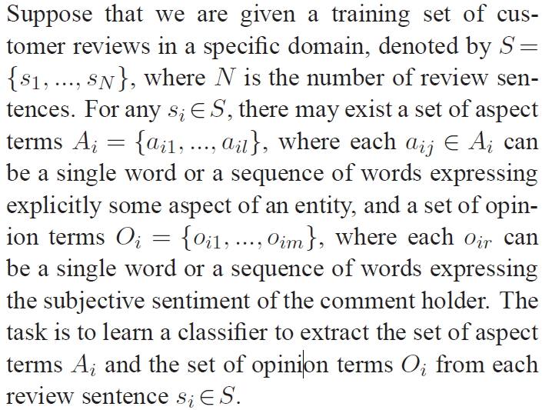

This task can be formulated as a sequence tagging problem by using the BIO encoding scheme.

“BA” (beginning of aspect), “IA” (inside of aspect), “BO” (beginning of opinion), “IO”

(inside of opinion), and “O” (others). Let L = {BA, IA,BO, IO,O}.

**4 Recursive Neural CRFs**

RNCRF consists of twomain components:

1) a DT-RNN to learn a high-level representation for each word in a sentence.

2) a CRF to take the learned representation as input to capture context around each word for explicit aspect and opinion terms extraction.

**4.1 Dependency-Tree RNNs**

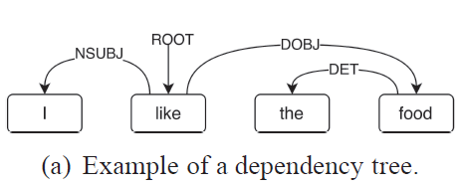

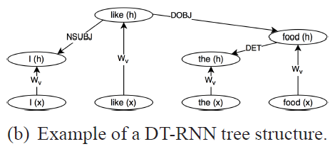

**4.2 Integration with CRFs**

CRFs are a discriminant graphical model for structured rediction.

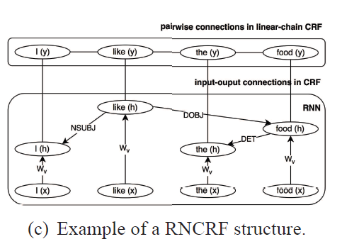

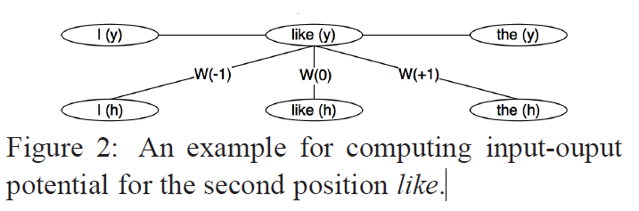

**4.3 Joint Training for RNCRF**

**5 Discussion**

The most important advantage of RNCRF is the ability to learn the underlying dual propagation between aspect and opinion terms from the tree structure itself.

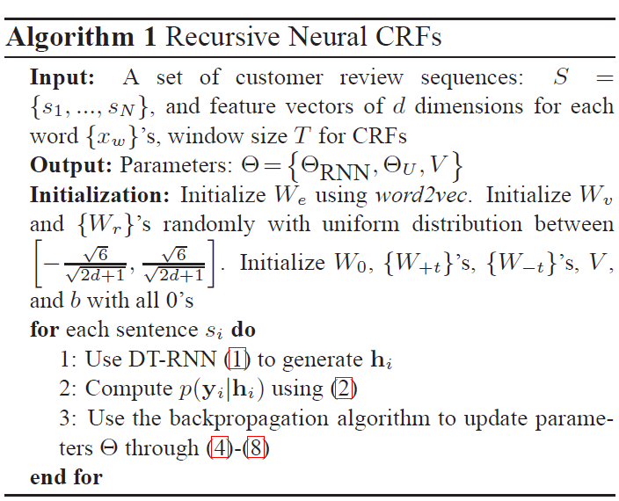

**5.1 Adding Linguistic/Lexicon Features**

**6 Experiment**

**6.1 Dataset and Experimental Setup**

**6.2 Experimental Results**

**7 Conclusion**